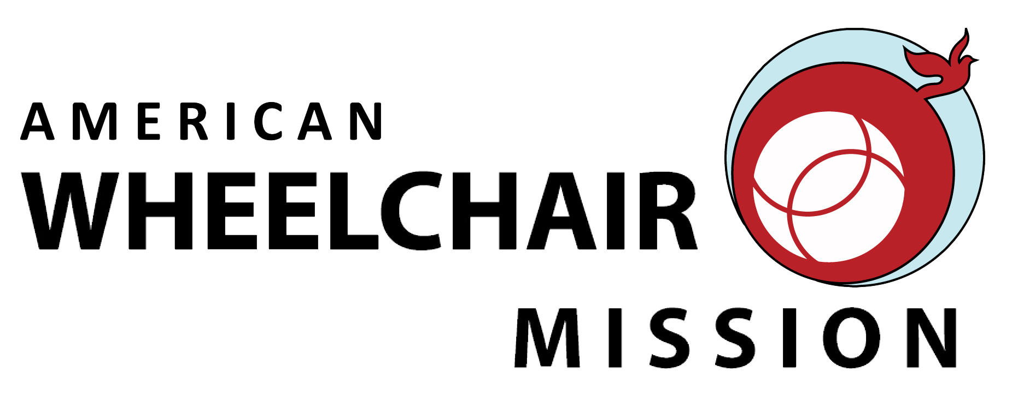

Direct Response Wheelchair Program

$150 will deliver a brand new wheelchair to a child, teen or adult in need of Hope, Dignity, Freedom and Independence.

○ $150 ○ $300 ○ $450 ○ Other $_________________ (Any amount is greatly appreciated)

Donor/Contact Name _____________________________________________________________________________

Address ___________________________________________________________________________________________

City ______________________________________ State______________ Country_______ Zip__________________

Telephone _____________________________E-mail _____________________________________________________

○ Check enclosed ( ○ I am interested in attending a wheelchair distribution )
Credit Card ○Visa ○MasterCard ○American Express ○ Discover

Name as it appears on card _________________________________

Card Number ______________________________________________ Exp. Date ___________________

Signature ___________________________________________________

With a donation of $150 you will receive a beautiful certificate of thanks with a photo of a wheelchair recipient.

CERTIFICATE WILL READ: American Wheelchair Mission wishes to thank:
○ Donor (above)

○ Other ______________________________________________________________

For the Gift made:
○ No designation ○ In the Name of ○ In Honor of ○ In Memory of

____________________________________________________________________
○ No Certificate Please

▌ PLEASE MAKE CHECK PAYABLE TO: ▌

American Wheelchair Mission
Mail Contribution(s) To: c/o Chris Lewis
2505 Anthem Village Dr., Suite E-602
Henderson, Nevada 89052 USA
For more information: E-mail clewis@amwheelchair.org – (702) 580-0705 - Fax (702) 580-5668

To watch videos of wheelchair distributions, please visit:

WWW.AMWHEELCHAIR.ORG

